LGE Internal Use Only

LGE VS [OEM NAME] [PROJECT NAME]

HSI (Hardware Software Interface) Specification

|  |  |  |  |  |  |  |  |  |  |  |  |  |  |  |  |  |  |  |  |  |  |  |  |  |  |
| --- | --- | --- | --- | --- | --- | --- | --- | --- | --- | --- | --- | --- | --- | --- | --- | --- | --- | --- | --- | --- | --- | --- | --- | --- | --- |
| **About This Template**   * Template Name: LGE_VS_SysAD_T02_HSI Specification * Management Department: VS SW Process Team * Revision History  |  |  |  |  |  | | --- | --- | --- | --- | --- | | Version | Date | Comment | Author | Approver | | 1.0 | 2016-09-30 | Initial Release  (Refer to System Requirements Specification template of 'Foton S7N1' task) | VC Smart SW Process Team | VC Smart QE FD | | 1.1 | 2018-04-26 | Separate MICOM HSI | VC Smart SW Process Team | VC Smart QE FD | | 1.2 | 2019-03-08 | Update due to annual organization restructuring (VC --> VS) | VS SW Process Team | VS SW Process Team Leader | | 1.3 | 2021-08-20 | Updated security notice of this template  (Before: LGE Confidential->After: LGE Internal Use Only).  Security level related note (the last sentence in red color below | VS SW Process Unit | VS SW Process Unit Leader |  * **The Blue Font** in the template contents is an example, so it should be written according to the project situation. * Since this template is not 100% applicable to all projects, it should be tailored to the project size and characteristics. * Please DELETE this guideline page after HSI document is finished. * The notice “LGE Internal Use Only” is for this template itself. The document which use this template needs to be classified as suitable security level according to its content. |

About This Document

Document Information

|  |  |
| --- | --- |
| Issuing authority | VS OOO Team |
| Configuration ID | Configuration Item ID of CMBook |
| **Status of document** | In Progress / Approved / Released |

Revision History

|  |  |  |  |  |
| --- | --- | --- | --- | --- |
| Version | Date | Comment | Author | Approver |
| #.# | YYYY-MM-DD | OOOOOOO | OOO | OOO |
|  |  |  |  |  |
|  |  |  |  |  |
|  |  |  |  |  |
|  |  |  |  |  |
|  |  |  |  |  |
|  |  |  |  |  |
|  |  |  |  |  |
|  |  |  |  |  |
|  |  |  |  |  |

Purpose

Describe the use of this document.

Scope

Describe the scope of contents covered in this document.

Audience

Describe the target audiences (main stakeholders) of this document.

The scope covered in this document is

* OOOOOO
* OOOOOOO

Related Documents

List the referenced documents when writing this document.

Documents related to this document include:

* LGE, Customer Requirements Specifications, pjt_CRS, v1.0, [date]
* OOOOOOO

Table of Contents

1 Hardware Software Interface 1-6

*1.1* *MODEM Part* 1-6

*1.1.1* *SPI (MODEM to MICOM Interface)* 1-6

*1.1.2* *GPIO (MODEM to MICOM Interface)* 1-8

*1.1.3* *XXX* 1-9

*1.2* *MICOM Part* 1-10

# Hardware Software Interface

Describe the detailed hardware software interface based on the system interface described in the system design document. Describe the following items when describing the Hardware Software Interface.

* General Information
* Operation Mode
* Data format & Configuration parameters
* Hardware resources

## *MODEM Part*

### *SPI (MODEM to MICOM Interface)*

*MODEM uses SPI interface to communicate with MICOM.*

1. *General Information*

* *SPI is a synchronous serial data link named by Motorola that operates in full duplex mode. It is used for short distance, single mater communication, for example in embedded systems, sensors, and SD cards.*
* *Devices communicate in master/slave mode where the master device initiates the data frame.*

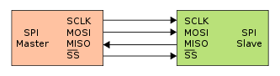

* *MODEM supports both mater and slave modes, with the master clock at 26 MHz and the slave clock at 26MHz.*
* *MODEM uses GSBI0 for SPI master mode. This mode is full-duplex transmission.*

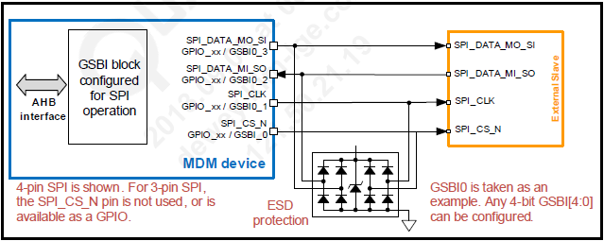

* *SPI driver layer is mapped to Qualcomm’s SIO layer. So SW developer can handle it as general SIO API.*
* *Allowed MAX packet size is 256 bytes included HDLC format.*
* *Allowed MAX data transfer frequency is 6MHz.*

1. *Operation Mode*
2. *Master mode : MODEM always maintains a master mode*
3. *Slave mode: MODEM is not used a slave mode.*
4. *Data format & Configuration parameters*

* *Data format uses HDLC format as below table.*

|  |  |  |  |  |
| --- | --- | --- | --- | --- |
| ***No*** | ***Name*** | ***Size (Byte)*** | ***Value*** | ***Type*** |
| *1* | *Command Code* | *1* | *0x4B* | *Mandatory* |
| *2* | *Sub System ID* | *1* | *0x55* | *Optional* |
| *3* | *Module* | *2* |  | *Optional* |
| *4* | *Function* | *1* |  | *Optional* |
| *5* | *Type* | *1* |  | *Optional* |
| *6* | *Payload Length* | *2* |  | *Optional* |
| *7* | *Payload* | *Variable* |  | *Optional* |
| *8* | *CRC 16* | *2* |  | *Mandatory* |
| *9* | *Close of Frame* | *1* | *0x7E* | *Mandatory* |

1. *Hardware resources*

* *SPI uses four lines (SPI_CS, SPI_CLK, SPI_TX, SPI_RX) is as below table.*

|  |  |  |  |  |  |
| --- | --- | --- | --- | --- | --- |
| ***Pad #*** | ***Pad Name*** | ***Configuration Function*** | ***Pad Voltage*** | ***Pad Type*** | ***Description*** |
| *L7* | *GPIO_31* | *GSBI0_3* | *P2* | *B-PD:nppukp*  *B* | *SPI Transmission* |
| *E7* | *GPIO_30* | *GSBI0_2* | *P2* | *B-PD:nppukp*  *B* | *SPI Receive* |
| *K7* | *GPIO_29* | *GSBI0_1* | *P2* | *B-PD:nppukp*  *B* | *SPI Clock* |
| *J7* | *GPIO_28* | *GSBI0_0* | *P2* | *B-PD:nppukp*  *B* | *SPI Chip Select* |

### *GPIO (MODEM to MICOM Interface)*

*MODEM uses GPIO interface to control MICOM for SPI communication.*

*(1)General information*

* *MODEM includes 99 GPIO pins, and each can be configured as a digital input or digital output for general purpose.*
* *GPIO input configuration : pull-up, pull-down, keeper, or no-pull*
* *GPIO output configuration : programmable drive current*
* *MODEM uses GPIO output configuration to send SPI control signal to MICOM.*
* *GPIO’s internal logical diagram is as below image.*

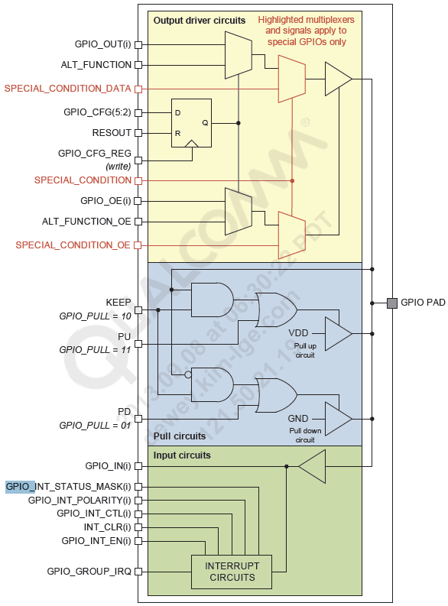

1. *Operation mode*
2. *Idle Mode*

*In this mode, SPI communication is not working*

*MODEM maintains low level signal*

1. *Ready Mode*

*In this mode, SPI communication is working.*

*MODEM changes a GPIO64 signal level from low level signal to high level signal.*

1. *Data format & Configuration parameters*

|  |  |  |  |  |
| --- | --- | --- | --- | --- |
| ***No*** | ***Name*** | ***Size (Byte)*** | ***Value*** | ***Description*** |
| *1* | *MCU_IDLE* | *1* | *0x0* | *MICOM’s SPI is an idle mode* |
| *2* | *MCU_WAKE_UP* | *1* | *0x1* | *MICOM’s SPI is a ready mode* |

1. *Hardware resources*

* *GPIO uses one line (MCU_WU)*
* *MODEM uses GPIO64 on MDM6200 to wake up MICOM before starting SPI communication.*

|  |  |  |  |  |  |
| --- | --- | --- | --- | --- | --- |
| ***Pad #*** | ***Pad Name*** | ***Configuration Function*** | ***Pad Voltage*** | ***Pad Type*** | ***Description*** |
| *AC13* | *GPIO_64* | *SDCC2_DATA_1*  *EBI2_A11* | *P2* | *B-PD:nppukp*  *B*  *DO* | *MICOM*  *Wake Up* |

### *XXX*

## *MICOM Part*

*Attach MICOM HSI file using ‘LGE_VS스마트_SysAD_T03_MICOM HSI.’ Template*